

PRESS RELEASE Prague, 26 June 2019

Passerinvest Group meets with the public for the third time in Roztyly brownfield

On Wednesday, 19 June, Radim Passer, the founder and CEO of Passerinvest Group, presented the future plans of the development of the locality of the former Interlov cutting plant at the third meeting with the public in the Interlov complex. Today the remnants of the buildings’ foundations can be found here, grown over with wild trees and bushes. The project architect, Martin Krupauer from A8000, explained the current plans in detail while Transport Engineer Václav Malina filled in the traffic solution. The mayor of Prague 11 Jiří Dohnal and Deputy Mayor Martin Sedeke also appeared at the event.
The revitalisation of the brownfield in Prague 11 increases the safety, permeability and growth of greenery. At the same time, it brings new housing and relaxation possibilities and new job opportunities. As part of the accompanying programme, parents with children could try sports/entertainment activities all afternoon in the already-finished part of the park above the former Interlov complex.

“The public discussion about our plan to renew the brownfield close to the Roztyly metro station is important to us, as the investor and developer. Our company philosophy is to be responsible and to think about the development and future of the locality. Instead of Prague expanding outward, we should concentrate on the areas in the city where it is necessary to urbanise them again. It is important to listen to the needs and requests of the long-time residents, but we also have to think more broadly about the younger generation, which brings the city district economic gains and development. Such meetings are an ideal means for sharing opinions and experiences and also for collecting suggestions from the public,” stated Radim Passer, the founder and CEO of Passerinvest Group, with regard to the meeting.

“The Nové Roztyly project is designed to provide housing to buy or to rent, a commensurate number of jobs, but also places for relaxation, whether in the form of sporting opportunities, green spaces, water surfaces or the prepared clubroom in the building for the new nursery school. Our plans also include another phase of the revitalisation of the park we are building next to the edge of the Krč forest, where it will newly be possible to relax and exercise. Everything is designed so that the project not only corresponds to the existing hygienic norms, current technological demands of modern buildings and requirements for the permeability of the area, but also the demands on environmental protection, all with regard to the permanent sustainability for several future generations,” added Martin Unger, the Technical Director of Passerinvest Group.

The first phase of the project a few years ago was to clean part of the edge of the Krč forest close to the Roztyly metro station, next to Za Větrem restaurant. A leisure-time meadow was created here with benches, a disc golf course and, in the autumn, the children from the nearby elementary school built a feed-trough. This year, another part was re-cultivated. A workout field will be made here and regular yoga and running lessons, for example, have started to be held here and are open to the general public. More information on the locality and the activities can be found on the webpages
www.krcakzije.cz.

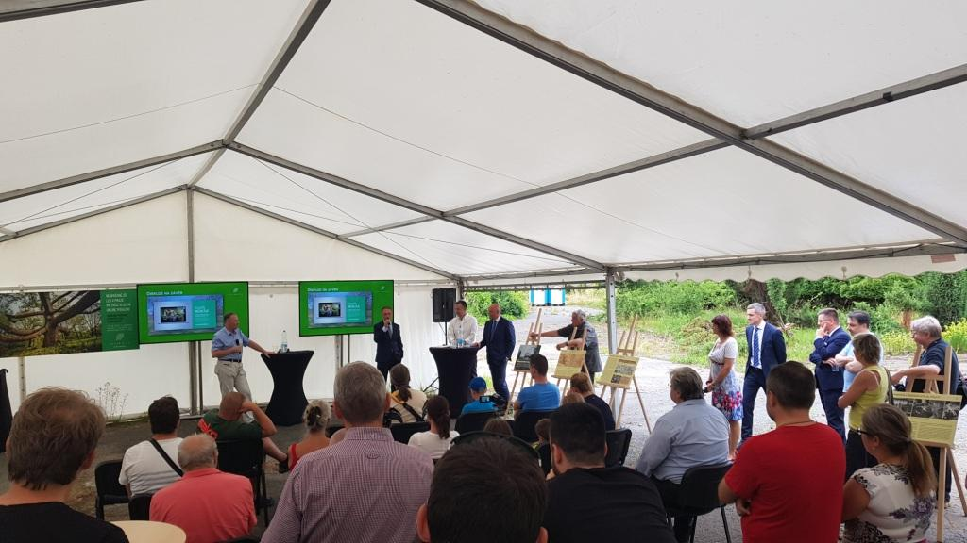

Meeting with the public and presentation of the project for the revitalisation of the Interlov brownfield by PASSERINVEST GROUP

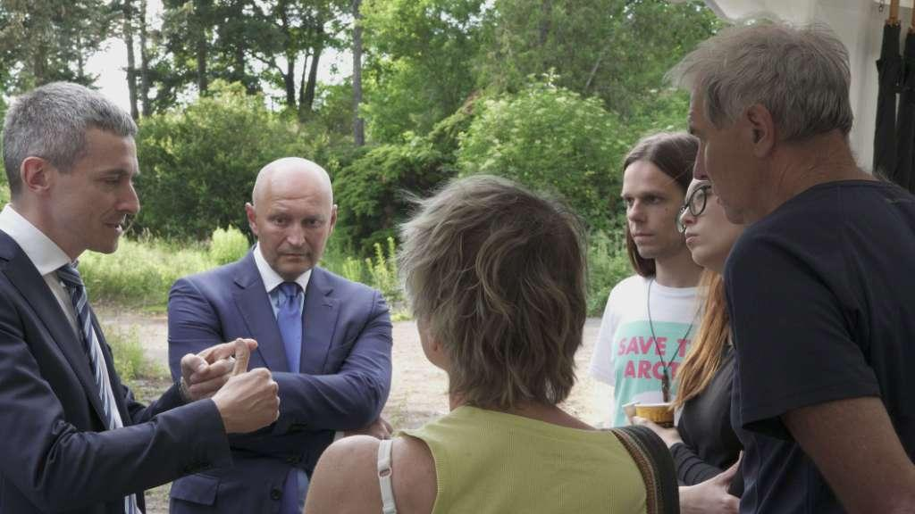

Radim Passer (second from left), the founder and CEO of PASSERINVEST GROUP, in a discussion with participants of the meeting

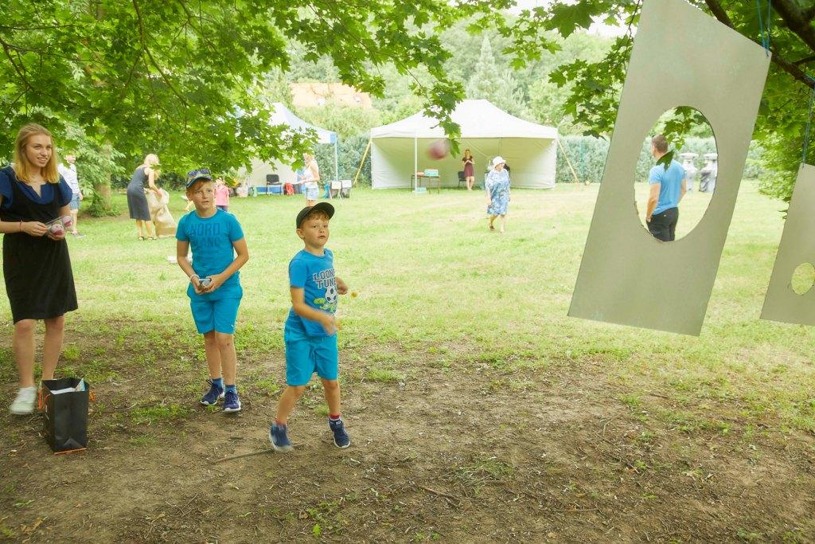

Family afternoon in the revitalised leisure-time meadow on the edge of the Krč Forest

You can get more information and photographs in print quality from:
Kristýna Samková, Head of PR and Marketing Department
PASSERINVEST GROUP, a.s.
Tel.: (+420) 221 582 111
E-mail: Kristyna.Samkova@Passerinvest.cz
www.passerinvest.cz, www.bbcentrum.cz

Marcela Štefcová
Crest Communications a.s.
Mobil: (+420) 731 613 669
E-mail: marcela.stefcova@crestcom.cz

About the company

PASSERINVEST GROUP, a. s., is a purely Czech development and investment company, whose name is primarily connected with the realisation of the multifunctional BB Centrum complex in Prague 4 – Michle. The company, established by Radim Passer in 1991, built a very good reputation both on a local and international level with this, the most successful and extensive project of its kind in Central Europe. This is not only to the credit of the quality of the realised projects and the high level of the provided services, but also due to the sense of fair play, a customer approach and especially responsibility to the society and the environment. PASSERINVEST GROUP also has other interesting investment and development projects in its portfolio, as well as projects that serve the general public and citizens of Prague.

